

MBARARA UNIVERSITY OF SCIENCE AND TECHNOLOGY
BUSINESS CASE REPORT
Banking customer details management system
A sub-system of the banking database management system
Group name :group A
Student name: Murungi Emmanuel Joshua
REG NUMBER : 2025/BCS/128/PS
COURSE :Database systems
Lecturer: MR Baguma Kenneth
Date : may 2025

1. Introduction
In the banking industry, data is the primary asset. Accurate and accessible customer information is the foundation for every transaction, loan, and support interaction. The Banking Customer Details Management System (BCDMS) is a specialized sub-system of the broader Banking Database Management System (BDMS) designed to manage the lifecycle of customer data—from onboarding and Know Your Customer (KYC) capture to account linkage.
In Uganda, many small-to-medium financial institutions (SACCOs and microfinance providers) rely on fragmented paper or spreadsheet-based records. This results in data duplication and compliance risks. The BCDMS, built on a centralized MySQL relational database, draws inspiration from the Finacle Core Banking System used by Stanbic Bank Uganda to provide a structured, professional solution for these challenges.

2. Justification (reasons for making the system )
The development of the BCDMS is driven by five core operational and strategic needs:
- Elimination of Data Fragmentation: Prevents the "duplicate customer" issue by creating a single "golden record" linked to all accounts and interactions.
- Enhanced Customer Service: Enables staff to access a full customer profile instantly, reducing response times and improving retention.
- Operational Efficiency: Automates manual data entry, reducing labor costs and errors associated with physical filing.
- Digital Transformation: Serves as the essential backend for mobile, internet, and API-based banking services.

3. Application Domain and User Groups
The system is designed for retail and commercial banking environments within East Africa. Access is governed by specific roles to ensure security and data integrity:
User Group | Role & Data Access
Bank Tellers | Capture onboarding data and update contact info; Read/Write access (no deletion of KYC).
CRM Managers | View full profiles and histories to tailor products; Full Read access.
Compliance Officers | Review/Approve KYC docs and flag suspicious profiles; Write access for status updates.
Branch Managers | Oversee branch-specific records and approve account openings.
IT/DBAs | Maintain system integrity and backups; System-level access (no personal data access).
Audit/Risk | Review logs for anomalies; Read-only access to all tables.

4. Design Assumptions
To ensure technical feasibility, the following assumptions were made:
- Environment: The bank has a stable LAN, role-based application interfaces, and a reliable power supply (UPS/Generator).
- Data Standards: Every customer is uniquely identified by a National Identification Number (NIN). While a customer may have many accounts, they have only one primary profile.
- Usage: The system handles 100–500 transactions per day per branch. Records are "soft-deleted" (marked inactive) to preserve audit trails.

5. Benefit-Cost Analysis
5.1 Tangible & Intangible Benefits
The BCDMS offers measurable financial gains and qualitative improvements:
- Time Savings: Reduces customer onboarding from 45 minutes to 10 minutes.
- Cost Reduction: Saves an estimated UGX 500,000 – 1,200,000 monthly in data correction labor and up to UGX 1,500,000 annually in physical storage costs.
- Intangible Gains: Improved customer experience through personalized service, better strategic decision-making via data analytics, and reduced fraud risk through automated KYC checks.
5.2 Cost Estimates
Item | Estimated Cost (UGX)
Hardware & Infrastructure | 21,000,000 – 33,000,000
Development & Migration | 20,000,000 – 42,000,000
Training (3–5 staff/branch) | 1,500,000 per person
Annual Maintenance | 4,000,000 – 6,000,000
Return on Investment (ROI): With total first-year implementation costs between UGX 50M and 91M, the system is expected to break even within 12 to 18 months due to efficiency gains exceeding UGX 120M annually.

6. Critical User Considerations
Successful adoption depends on addressing human factors:
- Data Discipline: Tellers may skip fields under pressure; the system uses mandatory fields and validation rules to enforce quality.
- Change Management: Resistance from staff accustomed to manual workflows is mitigated through early engagement and training.
- Digital Literacy: Interfaces must remain simple, using plain language and visual confirmations to support users with varying tech skills.
- Downtime Procedures: Given regional power/network instability, the bank must maintain rehearsed manual backup procedures to ensure service continuity.

7. Logical Design
The Logical Design focuses on the conceptual structure of the data, independent of the software used.
7.1 Entity-Relationship (ER) Overview
The system is built upon two core entities:
- Customer_Bio: Stores static personal attributes (Identity).
- Account_Details: Stores dynamic financial attributes (Value).
7.2 Relationship Schema
- Cardinality: One-to-Many (1:N).
- Description: A single customer in the customer_bio table can possess multiple records in the account_details table (e.g., a Savings account and a Current account).
- Integrity: We utilize Referential Integrity via Foreign Keys to ensure that no account can exist without a valid corresponding customer.
7.3 Normalization
The design adheres to the Third Normal Form (3NF):
- 1NF: All attributes are atomic (e.g., separating First and Last names).
- 2NF: All non-key attributes are fully functional on the Primary Key.
- 3NF: Transitive dependencies are eliminated (e.g., Branch details are linked via branch_id rather than repeating branch addresses in every account row).

8. Physical Design
The Physical Design translates the logical blueprint into actual machine-readable SQL code, focusing on performance and storage optimization.
8.1 Data Type Selection
- BIGINT: Used for account numbers to accommodate large numeric sequences.
- DECIMAL(15,2): Used for balances to ensure mathematical precision and prevent rounding errors common with the FLOAT type.
- ENUM: Used for account_type to restrict input to specific values ('savings', 'current'), ensuring data consistency.
- VARCHAR: Used for flexible string storage (Emails, Addresses) to save disk space.
8.2 Security and Constraints
- Primary Keys (PK): customer_id and account_number uniquely identify records.
- Foreign Keys (FK): account_details.customer_id references customer_bio.customer_id.
- Unique Constraints: Applied to the email field to prevent duplicate registrations.

9. Implementation (Tables)
9.1 Table 1: customer_bio
Column | Type | Constraint
customer_id | VARCHAR(16) | PRIMARY KEY
first_name | VARCHAR(50) | NOT NULL
last_name | VARCHAR(50) | NOT NULL
date_of_birth | DATE | NOT NULL
gender | CHAR(1) | CHECK (M/F)
email | VARCHAR(100) | UNIQUE
9.2 Table 2: account_details
Column | Type | Constraint
account_number | BIGINT | PRIMARY KEY
customer_id | VARCHAR(16) | FOREIGN KEY
account_type | ENUM | 'savings', 'current'
balance | DECIMAL(15,2) | Default 0.00
currency | VARCHAR(3) | Default 'USD'
status | VARCHAR(20) | Default 'Active'

9.3 table 3: customer_contact
Attribute Name | Data Type | Constraints
contact_id | INT | Primary Key, Auto Increment
customer_id | VARCHAR(20) | Foreign Key (References customer_bio), Not Null
phone_number | VARCHAR(20) | Not Null, Unique
home_address | VARCHAR(100) | Not Null
city | VARCHAR(50) | Not Null

9.4 loan_records
Attribute Name | Data Type | Constraints
loan_id | VARCHAR(20) | Primary Key, Not Null, Unique
customer_id | VARCHAR(20) | Foreign Key (References customer_bio), Not Null
loan_amount | DECIMAL(15,2) | Not Null, Default 0.00
loan_status | VARCHAR(20) | Not Null (e.g., 'Active', 'Cleared', 'None')

9.5 trancation_history
Attribute Name | Data Type | Constraints
trans_id | INT | Primary Key, Auto Increment
account_number | INT | Foreign Key (References account_details), Not Null
trans_type | ENUM('Deposit', 'Withdrawal') | Not Null
amount | DECIMAL(15,2) | Not Null
trans_date | TIMESTAMP | Default CURRENT_TIMESTAMP

9.6 branch_details
Attribute Name | Data Type | Constraints
branch_id | INT | Primary Key, Not Null, Unique
branch_name | VARCHAR(50) | Not Null
location | VARCHAR(50) | Not Null
branch_manager | VARCHAR(50) | Not Null

10 Examples of implementation ,queries and results obtained
10.1A query joining names and balance.Here I linked two tables using the foreign key and produced a list of customers showing their names and their current bank balance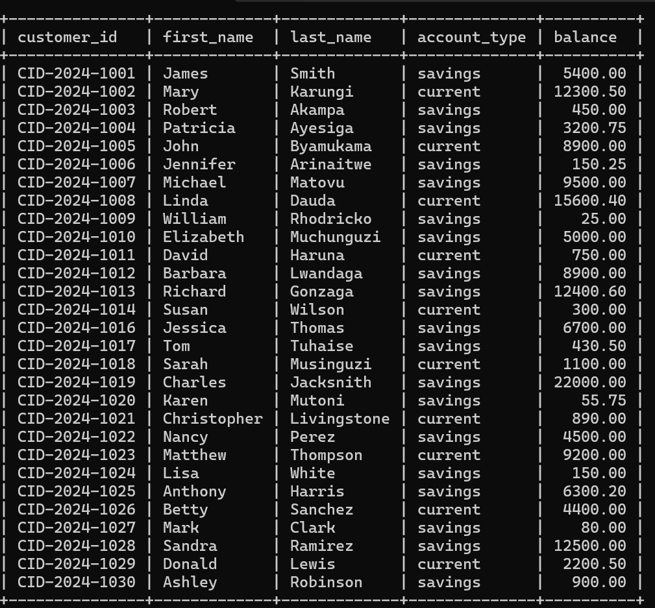

10.2 A query displaying the total average balance belonging to each gender.
I used mathematical functions like sum, count and avg to produce total average balance
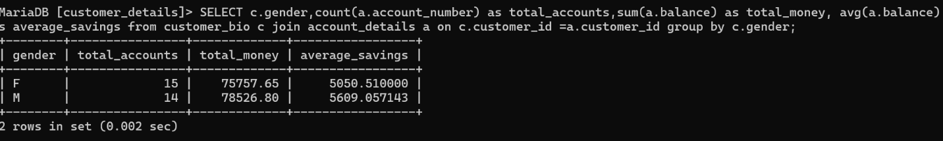
10.3 A query showing customers with current bank balances greater than 10000. This can help banks determine high value customers or if theres a certain amount you are required to have in order to have a credit card this helps get those customers easily .
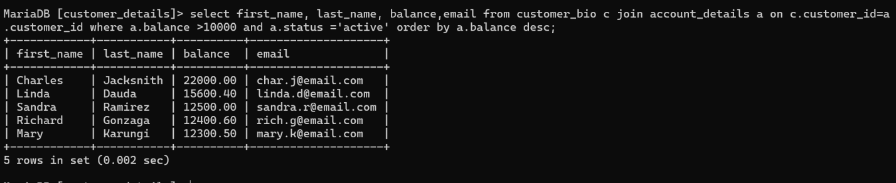
10.4 A query showing how data is updated in the database after a transaction takes place for this case a withdrawOf $500 by James Smith here we used his customer_id to refer to him. Here the data is modified without affecting the whole table .
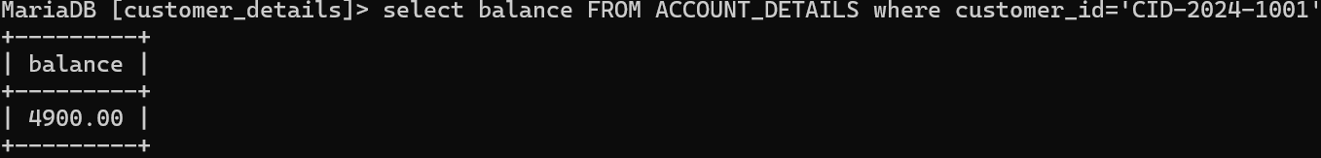
10.5 This query is used as a check whether there is data integrity in the system . this is because it doesn’t allow u to delete customers details when the account status is active.
Through the use of foreign key constraints I ensured that we cannot delete a customer record as long as they have active financial accounts.

10.6 creating a teller view . this ensures data security because it enables bank tellers to only see data relevant to them and not data like passwords, address and date of births of customers
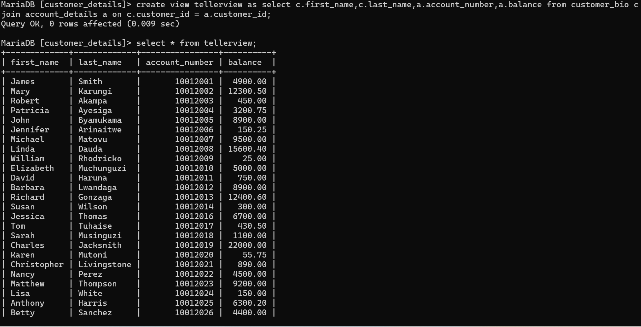
The different relationships in the 6 tables
- customer_bio to customer_contact (1:1 Relationship)
  - Link: customer_id
  - Logic: Every unique customer has exactly one set of contact details (phone, address).
- customer_bio to account_details (1:M Relationship)
  - Link: customer_id
  - Logic: One customer can own one or multiple bank accounts.
- customer_bio to loan_records (1:M Relationship)
  - Link: customer_id
  - Logic: One customer can apply for and hold multiple loan records over time.
- branch_details to account_details (1:M Relationship)
  - Link: branch_id
  - Logic: A single branch manages many different customer accounts.
- account_details to transaction_history (1:M Relationship)
  - Link: account_number
  - Logic: One bank account can have hundreds of deposit and withdrawal transactions.

Role in the the banking systems I was a database designer and this is how I participated . this was by creating a highly normalized relational structure that ensures data integrity and eliminates redundancy. The system is comprised of six core tables, strategically linked to reflect real-world banking operations through specific cardinalities and referential constraints.
1. Identity and Communication (1:1 Relationship)
Tables: customer_bio →→customer_contact
Linking Attribute: customer_id
Design Logic: I implemented a One-to-One (1:1) relationship between the customer’s biological identity and their contact information. By separating these, I have enhanced data security; personal identifiers are kept in the bio table, while frequently changing data like phone numbers and residential addresses are isolated in customer_contact. This ensures that every unique customer is mapped to exactly one set of contact credentials, preventing duplicate communication profiles.
2. Customer Ownership of Financial Assets (1:M Relationship)
Tables: customer_bio →→account_details
Linking Attribute: customer_id
Design Logic: Central to this system is the One-to-Many (1:M) relationship between a customer and their bank accounts. My design allows a single customer to own multiple accounts (e.g., Savings, Current, and Fixed Deposit) simultaneously. Through the customer_id foreign key, the system can instantly aggregate the total liquidity of any individual user across all their holdings.
3. Credit and Liability Management (1:M Relationship)
Tables: customer_bio →→loan_records
Linking Attribute: customer_id
Design Logic: To support the bank's lending operations, I established a One-to-Many (1:M) relationship between the customer and their loan history. This allows the bank to track various independent loan products—such as mortgages, auto loans, or personal credit lines—issued to a single customer over time. This structure is vital for calculating a customer's total debt-to-income ratio and creditworthiness.
4. Infrastructure and Branch Management (1:M Relationship)
Tables: branch_details →→account_details
Linking Attribute: branch_id
Design Logic: To represent the physical banking network, I linked the branch_details table to the account_details table using a One-to-Many (1:M) relationship. In this model, a single physical branch manages a vast portfolio of diverse accounts. This design enables the bank to generate localized reports, allowing management to see which branches are performing best in terms of account acquisition and total deposits.
5. Financial Auditing and Activity (1:M Relationship)
Tables: account_details →→transaction_history
Linking Attribute: account_number
Design Logic: For the most dynamic part of the system, I utilized a One-to-Many (1:M) relationship between a specific bank account and its transaction logs. While an account record is relatively static, it may generate hundreds or thousands of transactions. By linking them via the account_number, I have created a "ledger" effect where every deposit, withdrawal, and transfer is permanently recorded and traceable to the originating account for auditing purposes.

Summary of Design Integrity
By utilizing these specific relationships, the database prevents "orphaned" records (e.g., a transaction cannot exist without an account). I have applied Referential Integrity rules across all six tables, ensuring that any update or deletion in a parent table (like customer_bio) is managed safely in accordance with banking regulations. This architecture ensures the system is not only a tool for storage but a robust engine for financial management.

ER- DIAGRAM FOR A CUSTOMER DETAILS DATABASE MANAGEMENT SYSTEM
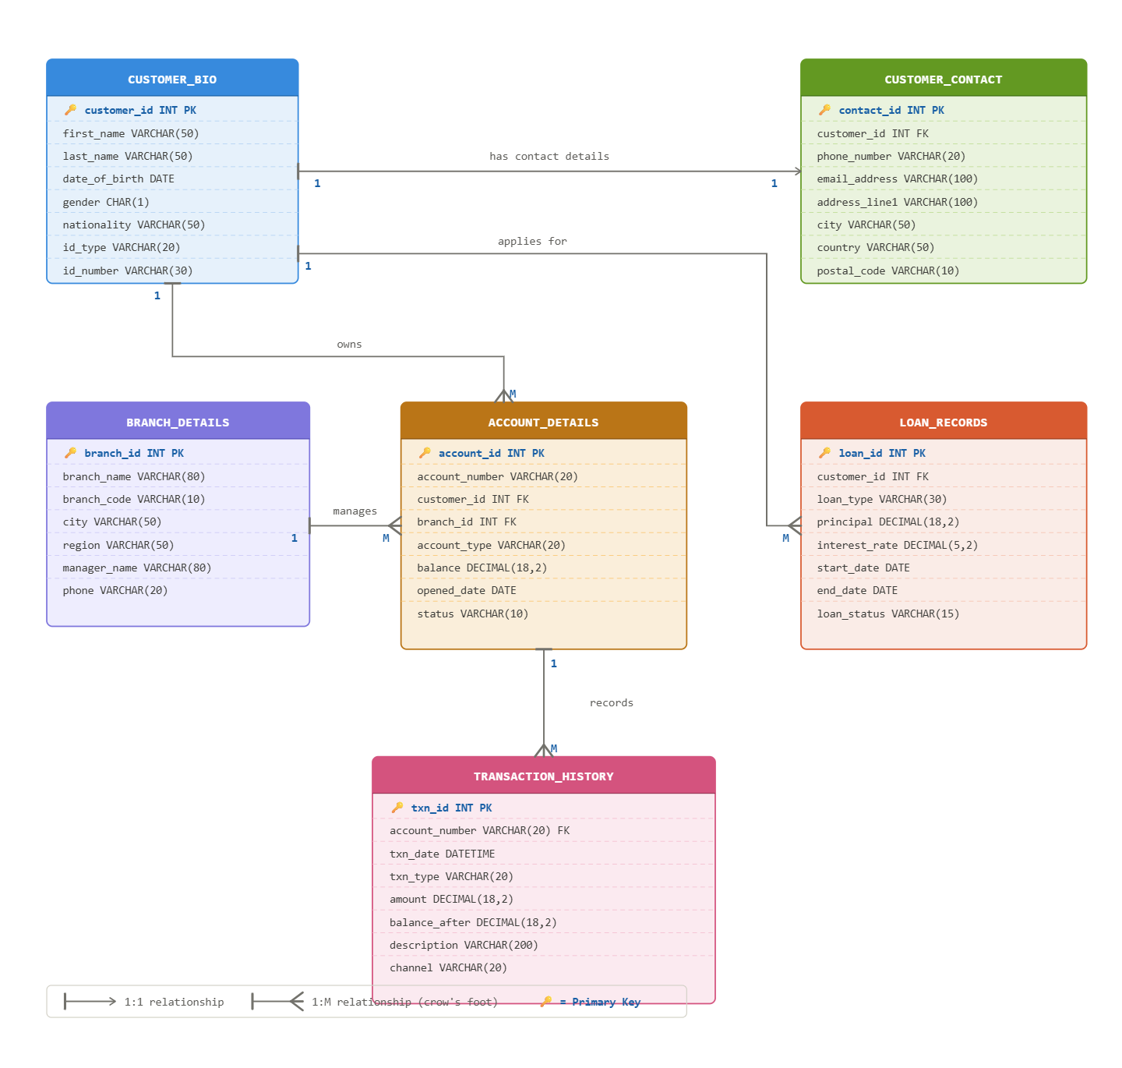7. Conclusion
The BCDMS is a high-value, low-risk solution to the fragmentation plaguing many Ugandan financial institutions. By replacing disconnected manual processes with a centralized relational database, the system ensures regulatory compliance and provides a scalable foundation for modern digital banking. Despite intangible costs like migration disruption, the tangible ROI and long-term strategic advantages make it an essential investment for any institution aiming for operational excellence.
Bibliography
- Elmasri, R., & Navathe, S. B. (2015). Fundamentals of Database Systems (7th ed.). Pearson. (Focus on Normalization and ER modeling).
- MariaDB Foundation. (2024). MariaDB Knowledge Base: Data Types and SQL Syntax. [Online]. Available at: https://mariadb.com/kb/
- Silberschatz, A., Korth, H. F., & Sudarshan, S. (2019). Database System Concepts (7th ed.). McGraw-Hill Education. (Used for reference on Transaction management and Relational Algebra).
- Sedgewick, R., & Wayne, K. (2011). Algorithms (4th ed.). Addison-Wesley. (Context for Binary Search Tree indexing used in system back-ends).

